Final Submission Document: JWT Authentication in ASP.NET Core Web API

Task Overview
This document contains a full solution to implement JWT-based Authentication and Authorization in an ASP.NET Core Web API.

Main Goals
1. Implement a login endpoint that returns a JWT token.
2. Secure API endpoints using [Authorize].
3. Validate and use the JWT token from a client (e.g., Postman).

Setup & Configuration
1. Create Project
C:\Users\KIIT01\Downloads>dotnet new webapi -n JwtAuthDemo
The template "ASP.NET Core Web API" was created successfully.

Processing post-creation actions...
Restoring C:\Users\KIIT01\Downloads\JwtAuthDemo\JwtAuthDemo.csproj:
Restore succeeded.
2. Install NuGet Package
PS C:\Users\KIIT01\Downloads\JwtAuthDemo> dotnet add package Microsoft.AspNetCore.Authentication.JwtBearer
3. Update appsettings.json
{
"Jwt": {
"Key": "ThisIsASecretKeyForJwtToken1234567",
"Issuer": "MyAuthServer",
"Audience": "MyApiUsers",
"DurationInMinutes": 60
},
"Logging": {
"LogLevel": {
"Default": "Information",
"Microsoft.AspNetCore": "Warning"
}
},
"AllowedHosts": "*"
}

Program.cs
using Microsoft.AspNetCore.Authentication.JwtBearer;
using Microsoft.IdentityModel.Tokens;
using System.Text;

var builder = WebApplication.CreateBuilder(args);

builder.Services.AddControllers();

// 🔐 Add Authentication
builder.Services.AddAuthentication("Bearer")
.AddJwtBearer("Bearer", options =>
{
options.TokenValidationParameters = new TokenValidationParameters
{
ValidateIssuer = true,
ValidateAudience = true,
ValidateLifetime = true,
ValidateIssuerSigningKey = true,
ValidIssuer = builder.Configuration["Jwt:Issuer"],
ValidAudience = builder.Configuration["Jwt:Audience"],
IssuerSigningKey = new SymmetricSecurityKey(
Encoding.UTF8.GetBytes(builder.Configuration["Jwt:Key"]))
};
});
builder.Services.AddAuthorization();
var app = builder.Build();
app.UseHttpsRedirection();
app.UseAuthentication(); // Important
app.UseAuthorization();
app.MapControllers();
app.Run();

LoginModel.cs
namespace JwtAuthDemo.Models
{
public class LoginModel
{
public string Username { get; set; }
public string Password { get; set; }
}
}

AuthController.cs
using JwtAuthDemo.Models;
using Microsoft.AspNetCore.Authorization;
using Microsoft.AspNetCore.Mvc;
using Microsoft.IdentityModel.Tokens;
using System.IdentityModel.Tokens.Jwt;
using System.Security.Claims;
using System.Text;

namespace JwtAuthDemo.Controllers
{
[ApiController]
[Route("api/[controller]")]
public class AuthController : ControllerBase
{
private readonly IConfiguration _config;
public AuthController(IConfiguration config)
{
_config = config;
}
[HttpPost("login")]
public IActionResult Login([FromBody] LoginModel model)
{
if (IsValidUser(model))
{
var token = GenerateJwtToken(model.Username);
return Ok(new { Token = token });
}
return Unauthorized();
}
[Authorize]
[HttpGet("secure")]
public IActionResult SecureEndpoint()
{
return Ok("You are authorized to access this secure endpoint.");
}
private bool IsValidUser(LoginModel model)
{
// Dummy check
return model.Username == "admin" && model.Password == "password";
}
private string GenerateJwtToken(string username)
{
var claims = new[]
{
new Claim(ClaimTypes.Name, username)
};
var key = new SymmetricSecurityKey(
Encoding.UTF8.GetBytes(_config["Jwt:Key"]));
var creds = new SigningCredentials(key, SecurityAlgorithms.HmacSha256);
var token = new JwtSecurityToken(
issuer: _config["Jwt:Issuer"],
audience: _config["Jwt:Audience"],
claims: claims,
expires: DateTime.Now.AddMinutes(Convert.ToDouble(_config["Jwt:DurationInMinutes"])),
signingCredentials: creds);
return new JwtSecurityTokenHandler().WriteToken(token);
}
}
}

HelloController.cs
using Microsoft.AspNetCore.Authorization;
using Microsoft.AspNetCore.Mvc;

namespace JwtAuthDemo.Controllers
{
[Route("api/[controller]")]
[ApiController]
public class HelloController : ControllerBase
{
[HttpGet("hello")]
[Authorize]
public IActionResult GetHello()
{
return Ok("Hello from protected API!");
}
}
}

Terminal: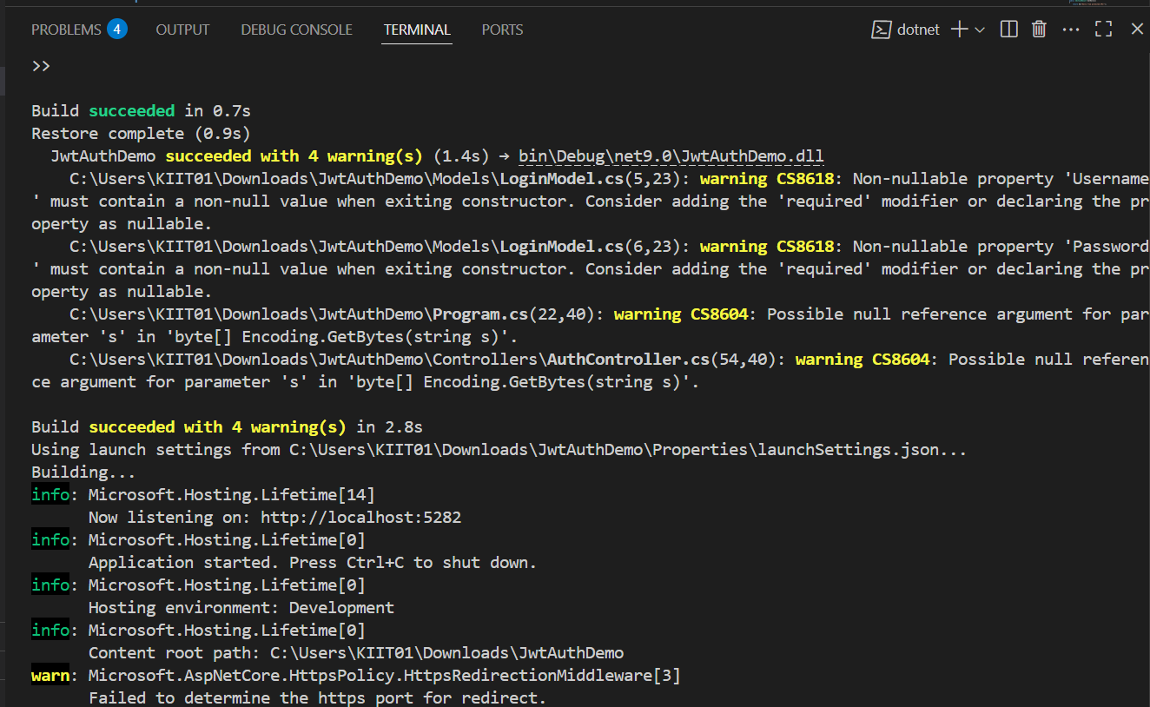

Tsting in Postman:
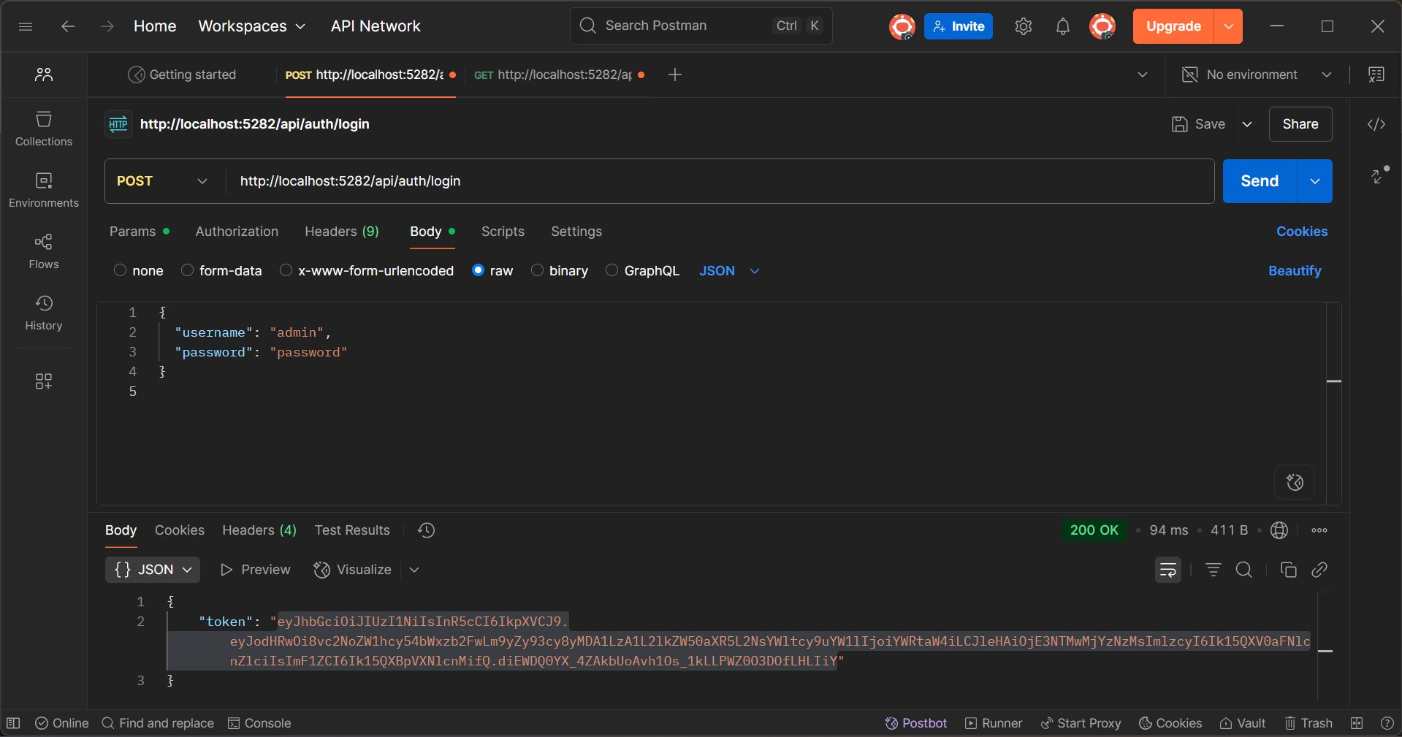

Conclusion
The project demonstrates secure login and JWT token validation using ASP.NET Core Web API.

